ENPM695 Final Project Report

Vinaykumar Yennam

Umi Hani Bacha

Pragya Gupta

Dheepshika Raghunathan

Contents

1. Task Group 1 – Evaluating the Security of a System 4

1.1. Task 1 – Determining the running and open services on the system 4

1.1.1. Nmap scan 4

1.1.1.1. Open Ports 4

1.1.1.2. Running services in the system 5

1.1.2. Nessus scan 5

1.2. Task 2 – Access the system by exploiting a vulnerable running or open service 5

1.2.1. Root Password 5

1.3. Task 3 – Detail the Flaws in the webserver running on the system 6

1.3.1. Version is not up to date 6

1.3.2. Possible compromise through Apache misconfiguration 6

1.3.3. Compromise through a vulnerability of the application 6

1.3.4. Compromising the system to vulnerabilities in DVWA and Mutillidae 6

1.3.4.1. DVWA Vulnerabilities 6

1.3.4.2. Multillidae Vulnerabilities 7

1.4. Task 4 – Crack Passwords 7

1.5. Task 5 – Find information stored in specific file 7

1.6. Task 6 – Define Attack Surface of the System 7

1.7. Task 7 – Develop Threat Model for the system and detail various Threat Vectors 8

1.7.1. General Threats 8

1.7.2. Threats to Open Ports 8

1.7.2.1. Port 22 – SSH 8

1.7.2.2. PORT 25 – SMTP 9

1.7.2.3. PORT 80 – HTTP 9

1.7.2.4. Port 110 – POP3 9

1.7.2.5. Port 143 – IMAP 9

1.7.2.6. Dovecot IMAP 9

1.7.2.7. Postfix SMTP 10

1.7.3. STRIDE Model 10

1.7.4. DREAD Model 13

1.7.4.1. PORT 22 – SSH 13

1.7.4.2. PORT 25 – SMTP 13

1.7.4.3. PORT 80 – HTTP 13

1.7.4.4. PORT 110 13

1.7.4.5. PORT 143 14

1.7.4.6. WEB SERVER 14

1.7.4.7. MAIL SERVER 14

1.7.4.8. BROWSER CLIENT 14

1.7.4.9. MySQL SERVER 14

1.7.4.10. AUTHENTICATION PROCESS 14

1.7.4.11. FILE SYSTEM 15

2. Task Group 2 – Improve the Security of a System 16

2.1. Task 1 – Develop Threat Model and Attack Surface Analysis 16

2.1.1. Nmap Scan of hardened System 16

2.1.2. Attack Surface Analysis 16

2.1.3. Nessus Scan 16

2.1.4. Threat Modelling 16

2.1.5. STRIDE Model 17

2.2. Task 2 – Lock down the Server 19

2.2.1. Setting up HTTPS 19

2.2.2. Removing banners to eliminate identifying information that the web server gives out 20

2.2.3. Jailing the web server 20

2.2.4. Hardening Process 21

2.3. Task 3 – Find Cogs, Inc’s secret file 21

# Task Group 1 – Evaluating the Security of a System

## Task 1 – Determining the running and open services on the system

Nmap and Nessus scans were run to identify the open and running services.

### Nmap scan

The Nmap scan helped us in identifying the open ports and running services on the system.

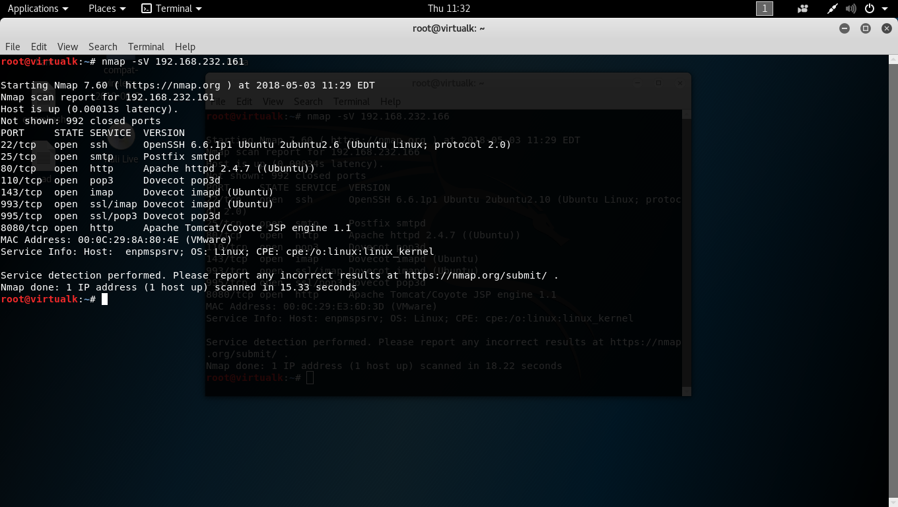

#### Open Ports

1. PORT 22/TCP – SSH (OpenSSH 6.6.1p1)
2. PORT 25/TCP – SMTP (Postfix smtpd)
3. PORT 80/TCP – HTTP (Apache httpd 2.4.7)
4. PORT 110/TCP – POP3 (Dovecot POP3d)
5. PORT 143/TCP – IMAP (Dovecot IMAP3d)
6. PORT 993/TCP – SSL/IMAP (Dovecot IMAPd)
7. PORT 995/TCP – SSL/POP3(Dovecot POP3d)
8. PORT 8080/TCP – HTTP (Tomcat/Coyote JSP engine 1.1)

#### Running services in the system

1. Dovecot/Postfix
2. MySQL
3. SSH
4. Apache2
5. Tomcat7

### Nessus scan



## Task 2 – Access the system by exploiting a vulnerable running or open service

1. The password for enpmuser account was guessed. This provided initial access to the system
   1. Password was **enpmuser**
2. Found the rest of the users by navigating to **/home** directory. Users found were
   1. smithy
   2. ppan
   3. chook
   4. admin
   5. enpmuser
3. DirtyCow local exploit used to gain root access
4. Brute Forced the password for **smithy** using Hydra
   1. The password was **password**
5. Exploited SQL Injection vulnerability in the running DVWA to find the credentials for users **ppan** and **chook.** 
   1. **SQLMap** was used to perform SQL Injection and retrieve database
   2. The passwords were
      1. ppan – NotTelling
      2. chook – JollyRoger
6. Found the credentials for Tomcat7
   1. tomcat – t0mcat
   2. admin - @dm!n

### Root Password

We made many attempts to find the root password. Initially we tried to brute force for the password using various detailed word lists.

After we received the hint that the password is a 14-character long string from a song in the movie ‘My Fair Lady’, we took up all the song lyrics and wrote a script to strip each line of any spaces or special characters. Then we found 14-character long strings. We then tried all these strings in all the cases.

After we received the final hint, we narrowed down the song to be ‘The rain in Spain’. We found 14-character strings - “the rain in spain”, up and down until”, in spain in spain, one a.m. two a.m.”

Then we used the below script to replace characters with numbers and metacharacters to create an exhaustive wordlist.



This script 3 generated the below wordlist, which we used to crack the root password.



Unfortunately, we were not able to find the password for root

## Task 3 – Detail the Flaws in the webserver running on the system

The web server running on the system is Apache 2.4.7. The various flaws associated with the same are

### Version is not up to date

The system uses Apache 2.4.7 which is an outdated version and has a number of vulnerabilities and attacks like DOS, XSS, Overflows and Remote code executions are easy. Apache 2.4.33 is the latest version available and is better than the older versions.

### Possible compromise through Apache misconfiguration

The default files and services provide a means for an attacker to reveal sensitive information and may also be used to elevate privileges. One way to prevent this is regular independent configuration assessments.

### Compromise through a vulnerability of the application

The functional level of the application may cause problems by selecting the valid and invalid inputs. Better is to not allow read/write access or compiler.

### Compromising the system to vulnerabilities in DVWA and Mutillidae

DVWA and Mutillidae are present which can be easy targets for the attackers. They are full of vulnerabilities and can allow easy attacks like SQL injections, Cross-Site Scripting (XSS), etc.

#### DVWA Vulnerabilities

1. Brute-force login
2. Command Execution
3. CSRF (Cross Site Request Forgery)
4. File Inclusion
5. File Upload
6. SQL Injection
7. Cross-Site scripting(XSS)
8. Insecure CAPTCHA
9. Weak Session IDs

#### Multillidae Vulnerabilities

1. Cross-site scripting
2. SQL injection
3. Broken authentication
4. Broken Access control
5. Sensitive Data Exposure

## Task 4 – Crack Passwords

|  |  |
| --- | --- |
| **User** | **Password** |
| enpmuser | enpmuser |
| ppan | NotTelling |
| smithy | password |
| chook | JollyRoger |
| root |  |

## Task 5 – Find information stored in specific file

This task was waived off because there was no such file in the machine

## Task 6 – Define Attack Surface of the System

The attack surface of the system is the open ports which an attacker can use as a source to get into the system.

* 22/TCP – SSH
* 25/TCP – SMTP
* 80/TCP – HTTP
* 110/TCP – POP3
* 143/TCP – IMAP
* 993/TCP – IMAPS
* 995/TCP – POP3S
* 8080/TCP – HTTP-PROXY

## Task 7 – Develop Threat Model for the system and detail various Threat Vectors

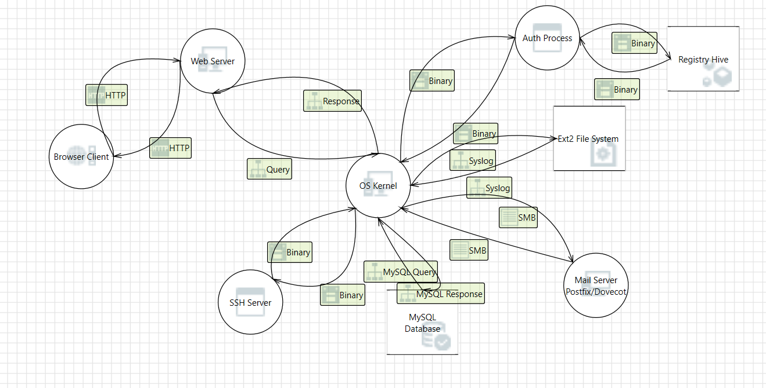

### General Threats

1. Weak passwords
2. Man-in-the-Middle attack
3. Sniffing of traffic
4. SQL injection
5. Cross-site scripting
6. Denial of service
7. Brute-Force
8. Dictionary attacks
9. Overflows
10. Remote code injection

### Threats to Open Ports

#### Port 22 – SSH

1. Weak passwords can make SSH and port 22 easy targets
2. Default or easily guessed user names and passwords

#### PORT 25 – SMTP

1. **Attacks using account enumeration**

Allow attackers to verify what mailing lists exist on a server.

1. **E-mail header disclosures**

The attackersmight find critical pieces of information like Internal IP address of the e-mail client machine, Software versions of the client and e-mail server along with their vulnerabilities as well as hostnames that can divulge the network naming convention

1. **Malware**

Mail systems are regularly attacked by such malware as viruses and worms. This generally happens if there is no antivirus software or if it’s not working.

1. **RELAY**

SMTP relay lets users send e-mails through external servers. Open e-mail relays aren’t the problem they used to be, but we still need to check for them. Spammers and hackers can use an e-mail server to send spam or malware through e-mail under the guise of the unsuspecting open-relay owner.

#### PORT 80 – HTTP

1. A number of Trojans/backdoors can be used on this port
2. Denial of Service
3. Sniffing of traffic
4. SQL injections, Cross site scripting attacks, Cross-site request forgery
5. Information leakage

#### Port 110 – POP3

1. No auditing of connections and attempts
2. Buffer overflows that allow compromise during login
3. Format string vulnerability allows attackers to execute arbitrary code
4. POP3 on port 110 is the older of the two popular protocols used to retrieve email from remote mail servers
5. Brute Force
6. Denial of service
7. Banner grabbing

#### Port 143 – IMAP

1. Format string vulnerability allows attackers to execute arbitrary code.
2. Remote attackers can cause Denial of service.

#### Dovecot IMAP

1. Brute force attacks
2. Denial of service attacks
3. Parse attacks

#### Postfix SMTP

1. TLS based attacks (renegotiation attacks)
2. DoS
3. Unauthorized access
4. Server port kept busy by Storm zombies
5. SQL Injection
6. Man-in-the-Middle attacks to insert commands into encrypted SMTP sessions by sending a cleartext command that is processed after TLS is in place, related to a "plaintext command injection" attack.

### STRIDE Model

|  |  |  |  |  |  |  |
| --- | --- | --- | --- | --- | --- | --- |
|  | **SPOOFING** | **TAMPERING** | **REPUDIATION** | **INFORMATION DISCLOSURE** | **DENIAL OF SERVICE** | **ELEVATION OF PRIVILEGE** |
| Port 22(SSH) | Yes  If the attacker can replace the SSH keys, he can spoof the user identity. | Yes  Attacker can get access to the SSH code and tamper with it. | Yes  Attacker can use someone’s else credentials and later deny. | Yes  Disclose info about the protocol version, ubuntu version. | Yes  Connection can be refused.  Users can be blocked after certain attempts | Yes  Attacker can compromise the SSH code running with high privilege and cause EOP. |
| PORT 110(POP3) | Yes  Attackers can spoof the mails by simply setting the display name or “from” field of outgoing messages to show a name or address other than the actual one which the message is sent. | Yes  Attackers can use the format string vulnerabilities and access the system | Yes  It is possible that the sender will deny that he sent the message.  can be dealt by using SSL/TLS. | Yes  Attackers can use banners to leak information regarding the system. | Yes  Remote attackers can cause denial of service. | Yes  The attackers can send phishing emails and ask the users for their credentials. |
| PORT 143(IMAP) | Yes  Attackers can spoof the mails by simply setting the display name or “from” field of outgoing messages to show a name or address other than the actual one which the message is sent. | Yes  Attackers can use the format string vulnerabilities and access the system. | Yes  A sender can deny that a particular message came from him. | Yes  If attackers use format string vulnerability present, they can leak any information they want. | Yes  Remote attackers can cause dos. | Yes  The attackers can send phishing emails and ask the users for their credentials. |
| PORT 25-SMTP | Yes  Attackers can exploit SMTP by setting up their own MTA (message transfer agent | Yes  Attackers can use the vulnerabilities in the mail server and access the system | Yes  A sender can deny that a particular message came from him. | Yes  Attackers can use account enumeration to get information about the mailing lists. | Yes  An attacker can use a flooding attack to cause denial of service. | Yes  The attackers can send phishing emails and ask the users for their credentials. |
| Port 80  HTTP | Yes  Attackers can use HTTP Flood attacks and cause IP spoofing. | Yes  If web server gets access to memory or given the ability to control what browser client executes |  | Yes  The attacker can grab banners and disclose file paths. | Yes  The attacker can use HTTP GET or POST requests to cause a DDOS attack | Yes |
| Port 8080  Apache tomcat | Yes  Attackers can use the vulnerabilities in tomcat to spoof the name of the target user and client IP address | Yes  Attackers can use SQL injection, CSRF, memory corruption and tamper with the information. |  | Yes  Attackers can use vulnerabilities in tomcat to get access to sensitive information | Yes  Attackers can use vulnerabilities in common file uploads and cause denial of service. | Yes  Attackers can get unrestricted access to global resources. |
| Web server | Yes  Web Server may be spoofed by an attacker and this may lead to unauthorized access to Authentication Process | Yes  The web server could be a subject to a cross-site scripting attack because it does not sanitize untrusted input | Yes  Web Server claims that it did not receive data from a source outside the trust boundary | Yes  Sniffing attacks are very common | Yes  The attacker can cause the web server to halt, stop or run slowly. | Yes  An attacker may pass data into web server in order to change the program flow execution. |
| Mail Server | Yes  The attacker can use the user credentials to send email to other users | Yes  Attacker can edit the mail boxes. | Yes  Attacker can send a mail on behalf of a legitimate user and later deny it | Yes  The attacker can  get access to the mail server and get the information in the mails | Yes  The attacker can change user password and stop them from accessing the system | Yes  Attacker can get access to the code behind the mail server and cause EOP. |
| Browser Client | Yes  Browser Client may be spoofed by an attacker and this may lead to unauthorized access to Web Server. | - | Yes  The client might deny that it tried accessing the web server. | - | - | - |
| MySQL Server | Yes  Attackers can access to the server if weak passwords are used. | Yes  SQL injection attacks are possible if vulnerabilities are found |  | Yes  Credentials / data flow can be sniffed by the attacker. | Yes  Requests can be timed out if resource consumption n attacks are not dealt with | Yes  the attacker can use SQL injection, unauthorized access or eavesdropping to elevate privilege. |
| Authentication Process | Yes  Authentication Process may be spoofed by an attacker and this may lead to information disclosure by Web Server | Yes  The authentication process could be a subject to a cross-site scripting attack because it does not sanitize untrusted input | Yes  Authentication Process claims that it did not receive data from a source outside the trust boundary | Yes  Credentials / data flow can be sniffed by the attacker | Yes  Requests can be timed out if resource consumption attacks are not dealt with. | Yes  Authentication Process may be able to remotely execute code for Web Server |
| File System |  | Yes  Attacker can edit the text files on the file system |  | Yes  Credentials / data flow can be sniffed by the attacker | Yes  Requests can be timed out if resource consumption attacks are not dealt with. |  |

### DREAD Model

|  |  |  |  |
| --- | --- | --- | --- |
|  | High - 3 | Medium - 2 | Low - 1 |
| **(D) – Damage potential** | High damage to the system | Medium damage to the system | Low damage to the system |
| **(R) Reproducibility** | Very easy to reproduce | Requires one or two steps to be reproduced | Very hard or impossible |
| **(E) – Exploitability** | Very easy even using a browser | Tools required to perform exploits | Advanced programming knowledge required |
| 1. **– Affected users** | All the users | Many but not all users | Very few users |
| **(D) – Discoverability** | Very easy to discover vulnerability | Can be found using monitoring or guessing techniques | Very hard to find- requires source code. |

#### PORT 22 – SSH

|  |  |  |  |  |  |  |
| --- | --- | --- | --- | --- | --- | --- |
| Threats on Port 22 (SSH) | D | R | E | A | D | Risk value |
| SSH key replacement | 3 | 1 | 1 | 3 | 1 | 9 |
| Tampering SSH code | 3 | 1 | 1 | 3 | 1 | 9 |
| Stolen credentials | 3 | 3 | 2 | 3 | 2 | 13 |
| OS information disclosure | 2 | 3 | 3 | 2 | 3 | 13 |
| Connection refusal(DOS) | 3 | 2 | 2 | 3 | 2 | 12 |
| Privilege escalation using SSH code | 3 | 1 | 1 | 3 | 2 | 10 |

#### PORT 25 – SMTP

|  |  |  |  |  |  |  |
| --- | --- | --- | --- | --- | --- | --- |
| Threats on Port 25 (SMTP) | D | R | E | A | D | Risk value |
| Account Enumeration | 2 | 2 | 3 | 3 | 2 | 12 |
| Flooding attacks. | 3 | 2 | 2 | 2 | 2 | 11 |

#### PORT 80 – HTTP

|  |  |  |  |  |  |  |
| --- | --- | --- | --- | --- | --- | --- |
| Threats on Port 80 (HTTP) | D | R | E | A | D | Risk value |
| SQL injection | 2 | 2 | 1 | 3 | 1 | 9 |
| Banner grabbing | 2 | 3 | 3 | 1 | 3 | 12 |
| DDOS | 3 | 2 | 2 | 3 | 1 | 11 |

#### PORT 110

|  |  |  |  |  |  |  |
| --- | --- | --- | --- | --- | --- | --- |
| Threats on Port 110 | D | R | E | A | D | Risk value |
| Format string vulnerability | 3 | 2 | 1 | 2 | 3 | 11 |
| Banner grabbing | 2 | 3 | 3 | 1 | 3 | 12 |
| Denial of service | 3 | 2 | 2 | 3 | 1 | 11 |

#### PORT 143

|  |  |  |  |  |  |  |
| --- | --- | --- | --- | --- | --- | --- |
| Threats on Port 143(IMAP) | D | R | E | A | D | Risk value |
| Format string vulnerability | 3 | 2 | 1 | 2 | 3 | 11 |
| Banner grabbing | 2 | 3 | 3 | 1 | 3 | 12 |
| Denial of service | 3 | 2 | 2 | 3 | 1 | 11 |

#### WEB SERVER

|  |  |  |  |  |  |  |
| --- | --- | --- | --- | --- | --- | --- |
| Threats on web server | D | R | E | A | D | Risk value |
| Unauthorized access using spoofing | 3 | 2 | 2 | 3 | 2 | 12 |
| Cross-site scripting | 2 | 2 | 2 | 3 | 2 | 11 |
| Repudiation | 2 | 2 | 1 | 2 | 3 | 10 |
| Sniffing attacks | 1 | 3 | 2 | 1 | 2 | 9 |
| Stop running due to DDOS attacks | 3 | 2 | 2 | 3 | 1 | 11 |
| Change the program flow execution | 3 | 1 | 1 | 3 | 1 | 9 |

#### MAIL SERVER

|  |  |  |  |  |  |  |
| --- | --- | --- | --- | --- | --- | --- |
| Threats on Mail Server | D | R | E | A | D | Risk value |
| Stolen credentials | 2 | 3 | 2 | 2 | 2 | 11 |
| Editing mail boxes | 2 | 2 | 1 | 2 | 1 | 8 |
| Mailing in behalf of the legitimate user | 2 | 3 | 1 | 1 | 2 | 9 |
| Disclosing information in mails by getting access | 2 | 3 | 1 | 2 | 2 | 10 |
| Change the user password cause DOS | 3 | 2 | 1 | 3 | 1 | 10 |
| Access to code behind server | 3 | 1 | 1 | 3 | 1 | 9 |

#### BROWSER CLIENT

|  |  |  |  |  |  |  |
| --- | --- | --- | --- | --- | --- | --- |
| Threats on Browser Client | D | R | E | A | D | Risk value |
| Spoofing to get unauthorized access | 3 | 3 | 2 | 3 | 2 | 13 |
| Deny accessing the system(repudiate) | 2 | 2 | 1 | 3 | 1 | 9 |

#### MySQL SERVER

|  |  |  |  |  |  |  |
| --- | --- | --- | --- | --- | --- | --- |
| Threats on MySQL server | D | R | E | A | D | Risk value |
| Weak passwords | 2 | 3 | 3 | 1 | 3 | 12 |
| SQL injection | 2 | 3 | 1 | 3 | 1 | 10 |
| Data flow sniffing | 1 | 3 | 2 | 2 | 2 | 10 |
| Requests timed out due to resource consumption | 3 | 3 | 3 | 3 | 1 | 13 |

#### AUTHENTICATION PROCESS

|  |  |  |  |  |  |  |
| --- | --- | --- | --- | --- | --- | --- |
| Threats on Authentication Process | D | R | E | A | D | Risk value |
| Spoofing | 1 | 3 | 2 | 2 | 2 | 10 |
| Cross-site scripting | 2 | 2 | 2 | 2 | 2 | 10 |
| Credential/data flow sniffing | 1 | 3 | 2 | 1 | 2 | 9 |
| Requests timed out(DOS) | 3 | 3 | 3 | 3 | 1 | 11 |
| Remote execution of code | 3 | 1 | 1 | 3 | 1 | 9 |

#### FILE SYSTEM

|  |  |  |  |  |  |  |
| --- | --- | --- | --- | --- | --- | --- |
| Threats on  File System | D | R | E | A | D | Risk value |
| Editing files on the system | 2 | 1 | 1 | 3 | 2 | 10 |
| Credentials sniffed | 1 | 3 | 2 | 1 | 2 | 9 |
| Requests timed out (DOS) | 3 | 2 | 3 | 3 | 2 | 12 |

# Task Group 2 – Improve the Security of a System

## Task 1 – Develop Threat Model and Attack Surface Analysis

### Nmap Scan of hardened System

We first did an Nmap scan to determine the ports that are currently open in the hardened system.

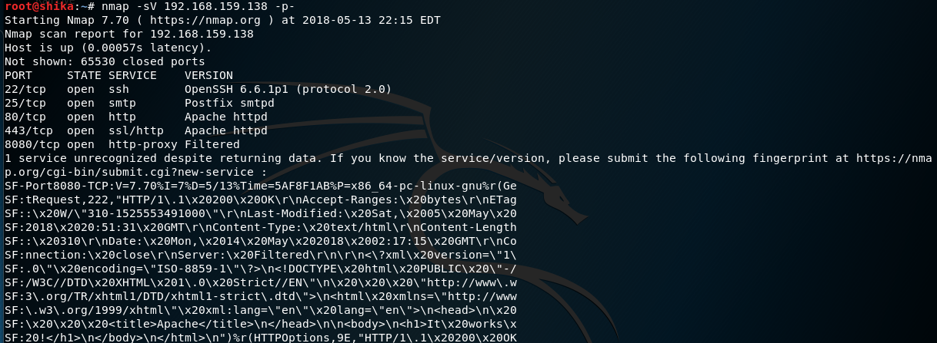

### Attack Surface Analysis

* Port 22/TCP – SSH (OpenSSH 6.6.1p1)
* Port 25/TCP – SMTP (Postfix SMTPD)
* Port 80/TCP – Apache HTTPD
* PORT 110/TCP – POP3 (Dovecot POP3d)
* PORT 143/TCP – IMAP (Dovecot IMAP3d)
* Port 443/TCP – Apache HTTPD
* Port 8080/TCP – HTTP-Proxy (Filtered)

### Nessus Scan



### Threat Modelling

Threat modelling diagram after hardening the system,

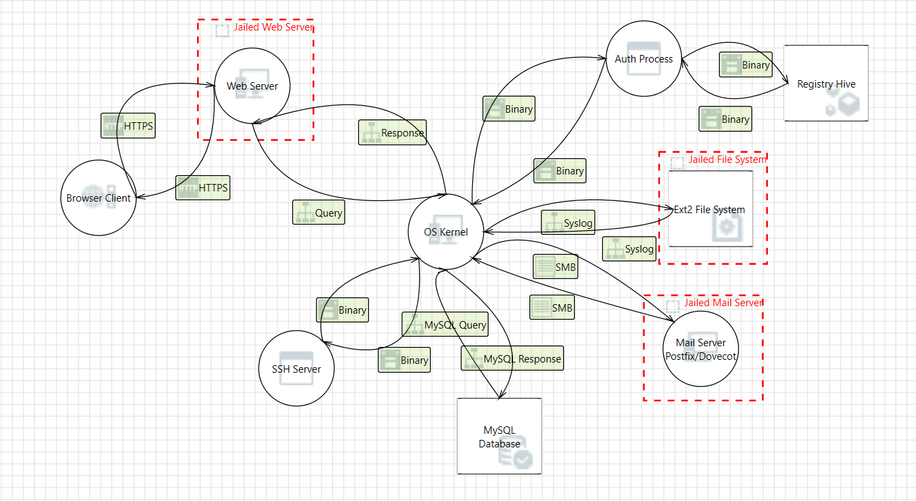

### STRIDE Model

|  |  |  |  |  |  |  |
| --- | --- | --- | --- | --- | --- | --- |
|  | **SPOOFING** | **TAMPERING** | **REPUDIATION** | **INFORMATION DISCLOSURE** | **DENIAL OF SERVICE** | **ELEVATION OF PRIVILEGE** |
| **PORT 80 – HTTPS** | No  We authenticated the server by changing the password. | Yes  Man-in-the-middle attacks are still possible.  Fiddler can be used. | Yes  Still be possible at the origin | No  Using SSH makes it encrypted. | Yes  The attacker can use HTTP GET or POST requests to cause a DDOS attack | Yes  We have use chroot thus the attackers can’t get any privileges. |
| **Port 25 – POSTFIX SMTP**  **Updated** | Yes  Attackers can exploit SMTP by setting up their own MTA(message transfer agent | Yes  Although updates the attackers can use the vulnerabilities in the mail server and access the system | Yes  A sender can deny that a particular message came from him. | No  We removed the banner thus making it difficult to see the version. | Yes  An attacker can use a flooding attack to cause denial of service. | Yes  The attackers can send phishing emails and ask the users for their credentials |
| **PORT 22 – SSH**  **Updated** | Yes  If the attacker can replace the SSH keys, he can spoof the user identity. | Yes  Attacker can get access to the SSH code and tamper with it. | Yes  Attacker can use someone’s else credentials and later deny. | Yes  Disclose info about the protocol version, ubuntu version. | No  Using maxauthtries limited the number of tries | Yes  Attacker can compromise the SSH code running with high privilege and cause EOP |
| **PORT 8080- Apache Tomcat**  **Updated** | No  authenticated tomcat changing password | Yes  Attackers can use SQL injection, CSRF, memory corruption and tamper with the information. |  | No  We removed the banner thus making it difficult to see the version | Yes  Attackers can use vulnerabilities in common file uploads and cause denial of service. | Yes  Attackers can get unrestricted access to global resources. |
| **Port 143-IMAP** | Yes  Attackers can spoof the mails by simply setting the display name or “from” field of outgoing messages to show a name or address other than the actual one which the message is sent | Yes  Attackers can use the format string vulnerabilities and access the system. | No  Since we set up an SSL connection difficult to do this | No  We removed the banner thus making it difficult to see the version | Yes  Remote attackers can cause denial of service. | Yes  The attackers can send phishing emails and ask the users for their credentials. |
| **Port 110 -POP3**  **Updated.** | Yes  Attackers can spoof the mails by simply setting the display name or “from” field of outgoing messages to show a name or address other than the actual one which the message is sent | Yes  Attackers can use the format string vulnerabilities and access the system | No  Since we set up an SSL connection difficult to do this. | No  We removed the banner thus making it difficult to see the version | Yes  Remote attackers can cause denial of service. | Yes  The attackers can send phishing emails and ask the users for their credentials. |

## Task 2 – Lock down the Server

### Setting up HTTPS

1. Enable a module using -sudo a2enmod ssl
2. Restart the web server after enabling the SSL

*sudo service apache2 restart*

1. Create a Self-Signed SSL Certificate
   1. Creating a subdirectory within Apache's configuration hierarchy to place the certificate files

sudo mkdir /etc/apache2/ssl

* 1. *sudo openssl req -x509 -nodes -days 365 -newkey rsa:2048 -keyout /etc/apache2/ssl/apache.key -out /etc/apache2/ssl/apache.crt*
  2. After answering some questions, the key and certificate will be created and placed in your /etc/apache2/ssl directory.

1. Configure Apache to Use SSL:
   1. Open the file with root privileges

*sudo nano /etc/apache2/sites-available/default-ssl.conf*

* 1. Make changes as required

1. Activate the SSL Virtual Host

*sudo a2ensite default-ssl.conf*

*sudo service apache2 restart*

This enables a new virtual host, which will serve encrypted content using the SSL certificate we created.

1. Testing the Setup

### Removing banners to eliminate identifying information that the web server gives out

* Apache default page- removing default data.
  + Editing /var/www/index.html
  + Removing the identifying information.
* Securing SSHd
  + Changing **maxAuthTries = 3** will limit the brute force limit to 3 per connection and refuse connection after.
* Removing identifying information from:
  + Mail Server – Removing Postfix banner number and version information in the scan
    - Sudo vi /etc/postfix/main.cf
    - Change the smtpd_banner line to “smtpd_banner = $myhostname”
    - sudo service postfix restart
  + Tomcat – We made changes in the server.xml file using
    - find / -name server.xml
    - Added a server parameter to this line to specify how we want Tomcat to respond when a user asks for the system version.
    - Connector port=8080”
    - Server= “Filtered”
    - We tried to find a file named ServerInfo.properties  to remove the version information of apache tomcat but couldn’t find the file.

### Jailing the web server

* Jailed the webserver and users
  + Used <https://olivier.sessink.nl/jailkit/index.html#intro> to download the JailKit
    - Jailing user’s **smithy chook enpmuser** using command

*jk_init -v -j /home/jail basicshell editors extendedshell netutils ssh sftp scp*

*jk_jailuser -m -j /home/jail smithy chook enpmuser*

* + - There were few dependency issues which were solved manually
  + For **Jailing web server**, the commands were

*jk_init -v -j /home/webjail apache2*

* + - Few dependency issues were solved manually
  + Created a jail.sh bash script with contents as

*jk_chrootlaunch -j /home/webjail -x /home/webjail/usr/sbin/apachectl -- start*

* + - This Bash script was made to run on every startup by editing the /etc/rc.d/rc.local startup file
  + And added this line in /etc/rc.d/rc.local

*sh /home/webjail/jail.sh*

### Hardening Process

1. Update all services as per ubuntu repository
   1. apt update
   2. apt upgrade
2. Purged and reinstalled MySQL from v5.5 to v5.6
3. Jailed the users enpmuser, chook admin and smithy
   1. Installed JailKit tool and used the following commands
   2. The jailed users were given limited bash commands and no sudo privileges
4. Changed the passwords for all the users
5. Changed passwords for tomcat users in tomcat-user.xml
6. Changed the name of DVWA-master and mutillidae to ENPM695_needs_a_lot_of_security_upgrades and ENPM695_needs_a_lot_of_security_upgrades_as_well
7. Kept the file ENPM_18.pdf in /root with permission as 700.
8. Removed sudo privileges for chook:

*userdel chook sudo*

1. File was placed in /root with only read, write and execute permissions for the root user:

*chmod 700 ENPM_18.pdf*

## Task 3 – Find Cogs, Inc’s secret file

The nmap scan screenshot of the team we got the Virtual Machine is attached below

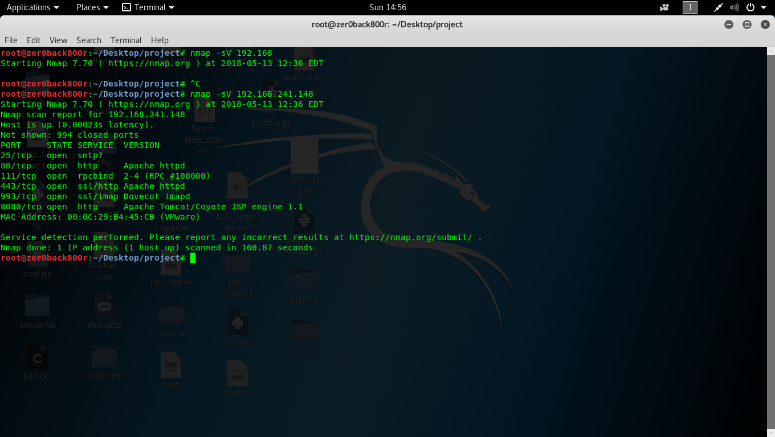

* SSH was hardened so that only known hosts were allowed. So hydra on SSH didn’t work.
* So, we tried attacking tomcat7. First, tomcat7 credentials were cracked using metasploit auxilliary scanner module. Later, used tomcat upload vulnerability to upload a reverse shell and got access to the system
* Didn’t have enough privileges to parse through the filesystem. So, used a local linux privilege escalation exploit dirty Copy On Write.
* Instantly, we got the root access. For continued access, we changed the root password to null.
* We logged in as root to find the secret file. Initially, the vm the team gave didn’t include a file.
* We asked the team to verify. Later, they uploaded the new vm. I followed the same exploit method. However, this time they changed the login credentials. We changed the default wordlist and used a wordlist that was 13 Gigs big in size. We divided the file into 4 parts, and all four individually tried to crack the login credentials. Finally, it was cracked. We used this credentials for further exploit.
* After getting access to the system, we found very difficult to find the file. Asked help from the team 11 about the location. It was in the /dev/sda3. We mounted the file and listed the directory. The File ENPM_11.pdf had no read, write or execute permissions for any user. So, we changed the permission using chmod 777 ENPM_18.pdf and later downloaded the file into thumb drive. We have also attached the file as a separate attachment.
* The MD5 checksum of the file is **107A462A48EAF735A78A98FA5464742F**
* And the content of the file is

